Do as shown between brackets : - 1 -
1 – we're using ( much - many - fewer ) electricity
( choose )
2 – we ( write - travel – drive ) on the paper
( choose )
3 – put on …………………
( write the opposite )
4 – radio - Tv - Table - washing machine
( under line the odd words )
5 – rad - -
Co - -
( complete )

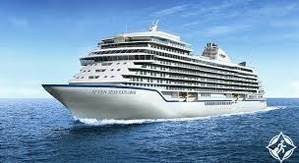
- Match : 1 – ship

2 -circle

3 - glasses

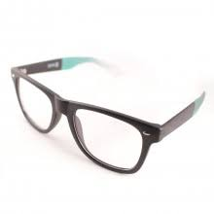
4 - bee

