What's the matter ? 1 -
......................................

2 – Choose the correct answer :
1 - It's ( alwayes - some times ) hot in the summer in Britin
2 - It ( often – always ) rains in Britin

3 – add ing for the following
1 – go
2 – shop

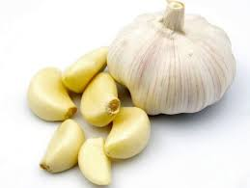
Match the following words with the pictures
1 – garlic
2 – tomato
3 – pepper
4 – plate
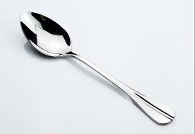
5 – spoon

Complete : -

1 – lu - - h .

2 – di - - er .

